Lab1_ Type Tree Designer

Objective

Equip you with the knowledge and understanding of the purpose of the Type Designer and creation of a type tree manually to rePad data from a flat file.

- This exercise also introduces component ranges.
- By completing the exercises you will learn how to use the Type Designer to:
- View and understand type properties.
- Open and close group windows components.
- Modify a type tree to create a new data field.
- Padd a component to a group type.
- Padd a component range to an optional component.
- Analyze and save a type tree.

Type Designer

The Type Designer is the design component used to specify, define, and manage type definitions in the form of type trees. A type tree is a data dictionary that defines how types are classified. The type tree files you create in the Type Designer are data definition files. Each object identified in your data is defined as a type in your type tree.

The Type Designer is used to create and maintain type trees, although type trees can also be created using the Type Tree Maker, the Importer Wizard, and the Database Interface Designer. Use the Type Designer to define:
- Properties for data structures.
- Data validation rules.
- Data as text or binary.
- Different character sets.

Type Tree

A type tree is the mechanism for defining each element of your data. Similar to a data dictionary, a type tree contains a collection of type definitions. A type tree describes the syntax, structure, and semantics of your data.
The syntax of data refers to its format. The format of data includes tags, delimiters, terminators, and other characters that separate or identify data breaks.

The structure of data refers to its composition, including repeating substructures, nested groupings, sequences, and choices.
The semantics of data refer to the meaning of the data, including rules for data values, relationships among parts of a large data object, and error detection and recovery.
One should be familiar with the specifications that define the data before attempting to create one.

A data file is a simple example. The file is made up of records and each record is made up of fields. In this case, there are three kinds of data objects: a file, a record, and a field. In a file of records, think of the data in terms of the three data objects. For example, one type defines the entire file; another type defines the entire record contained in that file. Other types in the same type tree define the data fields of the record.
A type tree has three data type Classifications:
- Group
- Category
- Item.
The tree has a root type and other types are connected to the tree through branches of the tree. The root type is the base type from which all other types Item, representing the data objects of all types in the tree.

Environment

Windows OS, WTX8.4 Design Studio.

List of components:

Employee.mtt

Procedure

Step1 :

Start menu->Programs-> WebSphere Transformation Extender 8.4 ->Design Studio->Design Studio.



Step 2 :
Open the WebSphere Transformation Extender Design Studio and click the OK button to accept the default workspace location or you can browse your own location.
Here location C:\WTXTraining\WTX8.4 has been used.
The workspace is the physical directory where your artifacts will be stored.

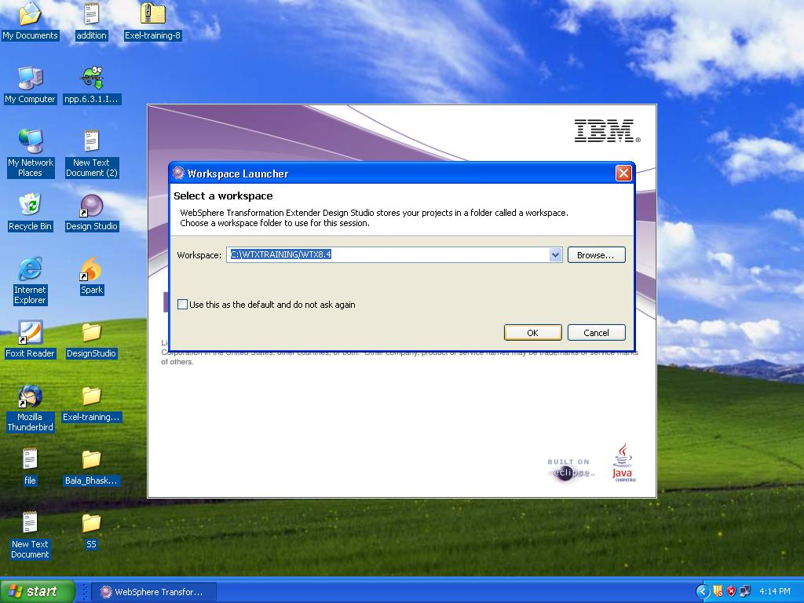

Step 3 :
Go to the file menu and select New->Extender Project to create a new project:

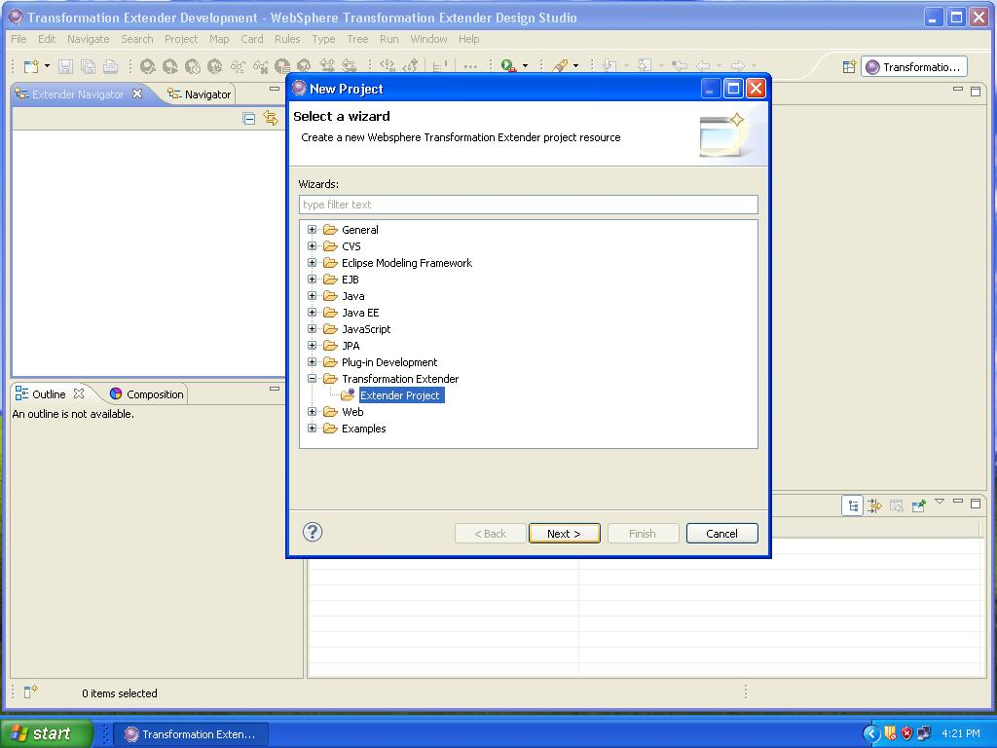

Step 4 :
Name this project WTX_Lab1 and accept the default location and click Finish.
You have created a subdirectory called C:\WTXTraining\WTX8.4 in your default workspace. You can use Windows Explorer to view it.
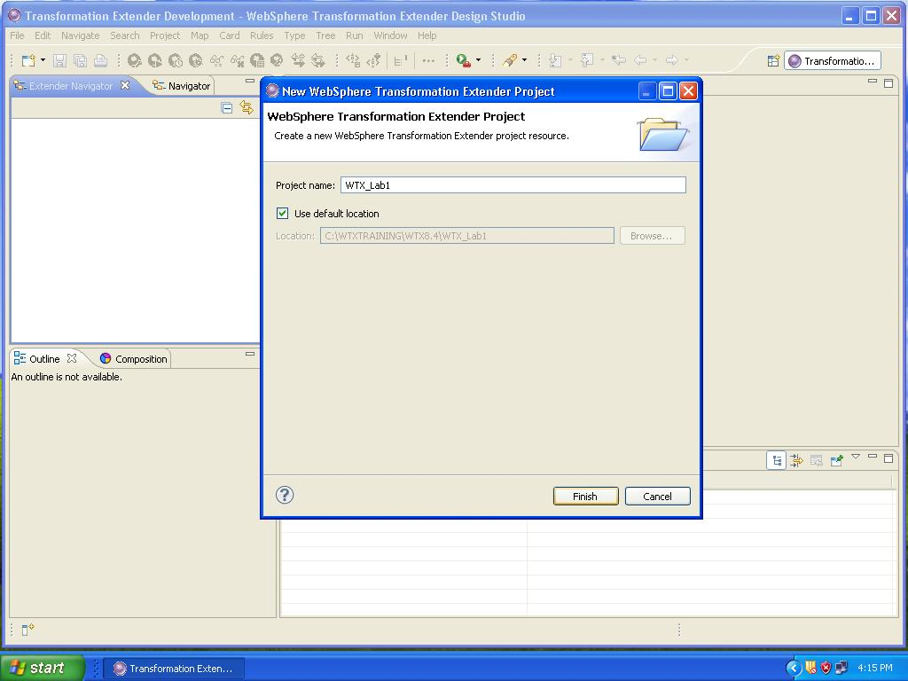

Step 5 :
Right-click on the Type Tree in the Extender Navigator or choose File ->New->Type Tree as shown below.

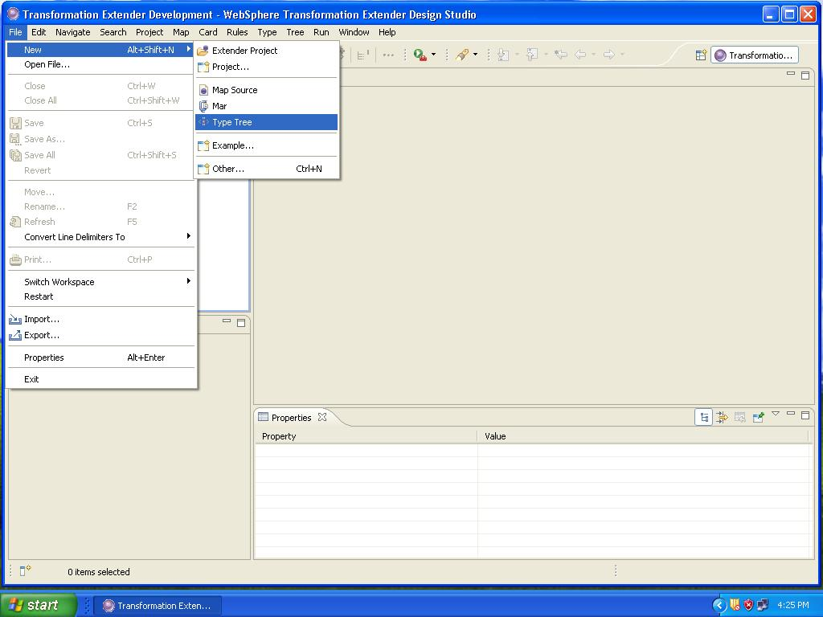

Step 6 :

Click WTX_Lab1 to move it to the “Enter or select the parent folder” window. Type Employee into the File name field. Click Finish.

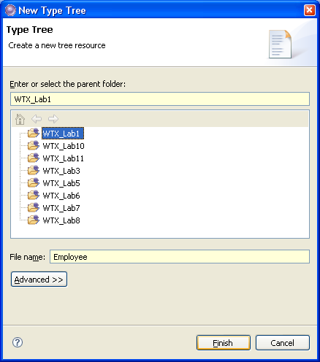

The new type tree - Employee is displayed under the project folder in the Extender Navigator. In the main window, a tab has been created for the new type tree from where you can begin Padding types that define your data to the “Root” type.

Step 7 :

Create a Details group. Right click on “Root” and Press “add”

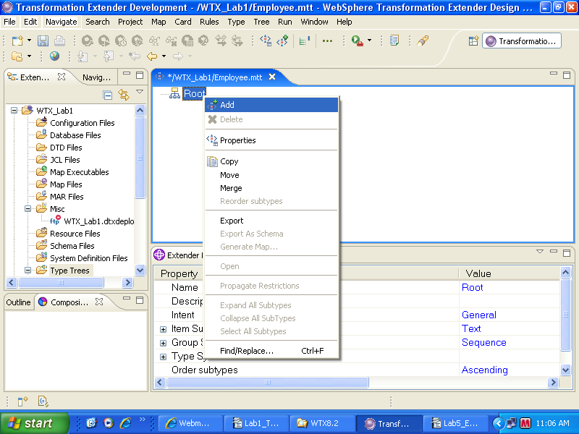
Click “YES” in the popup window.

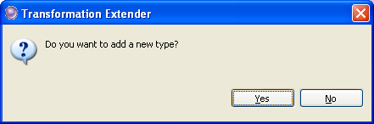

Step 8:

Change the cClass property to Group as shown below.

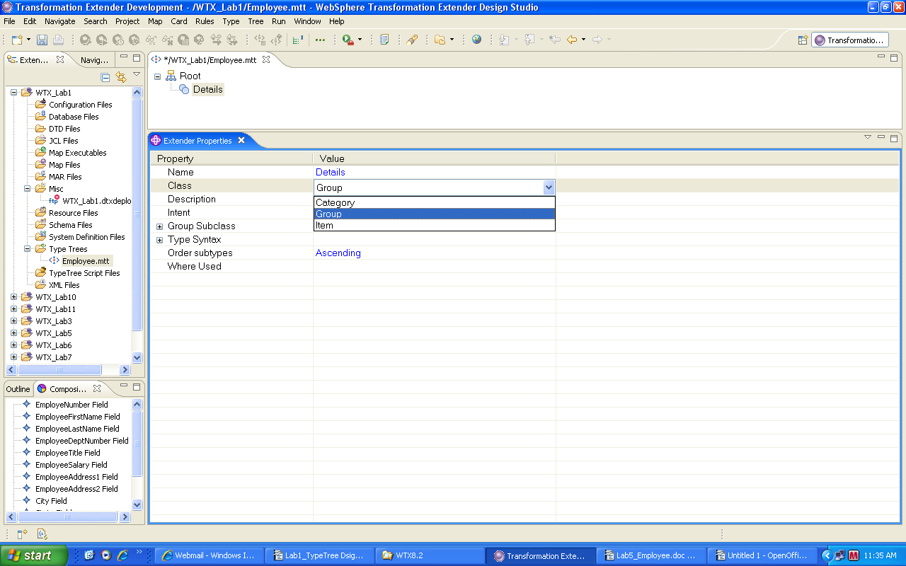

Click Yes in the pop window to change its type Class.

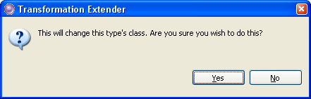

Step 9 :

Set the properties for the Details group

- Class properties as Group.
- Group SubClass as Sequence.
- Format as Explicit.
- Component Syntax as Delimited
- Delimiter as Literal (See Appendix A – for Delimiter as “Variable”)
- Value as “,” (Comma)
- Terminator as Literal
- Value as <CR><LF>

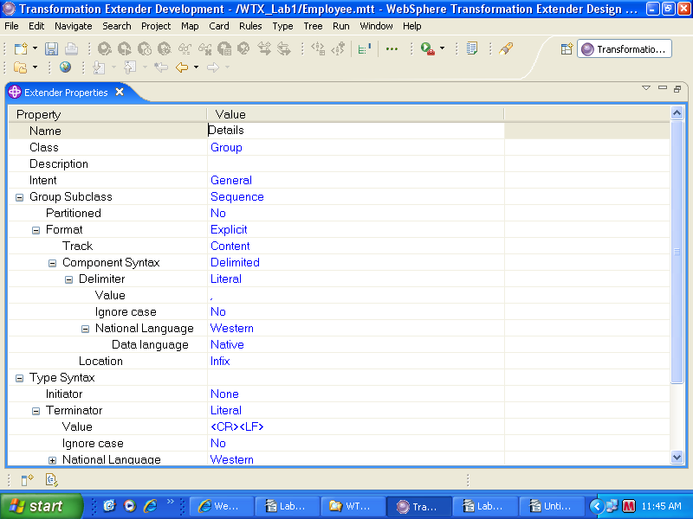

Step 10 :

Creating a Employee group.

Right click on “Root” and Press “add” and click “Yes” in the popup window.

Set the properties for the Employee group

- Class properties as Group.
- Group SubClass as Sequence.
- Format as Implicit.

Use default Properties as shown in figure below.

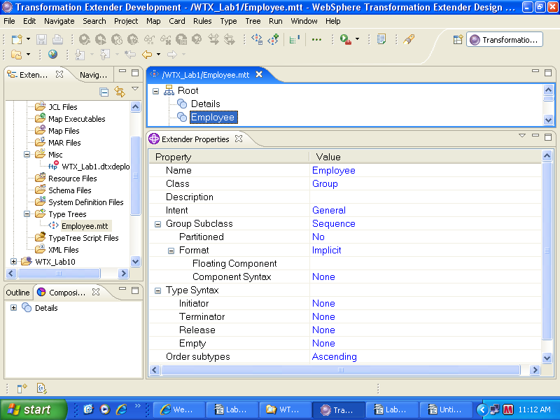

Step 11 :

Add an iItem to the type tree as Field (this will have a list of Item elements in hierarchical order)

Class properties as Item in properties window.
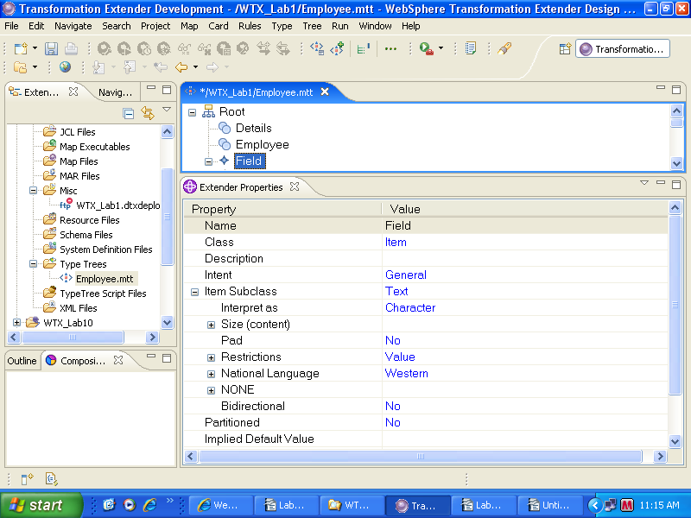

Step 12 :

Add the following Items to the iItem Field with the corresponding properties

- Employee Number
- EmployeeFirstName
- EmployeeLastNamex
- EmployeeDeptNumber
- EmployeeTitle
- Employee Salary
- EmployeeAddress1
- EmployeeAddress2
- City
- State
- Zip
- Country
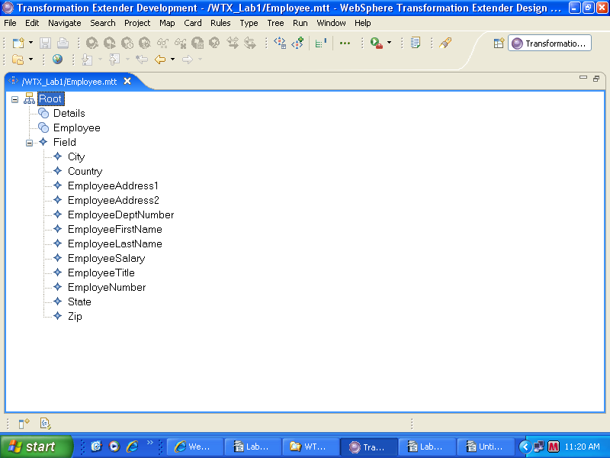

Set up the properties for each field.

Employee Number

- lClass properties as Item.
- IItem SubClass as Number
- IInterpret as Character
- PPresentation as Integer
- SSize Min as 0 and Max as 12.
- PPad as Yes (See Appendix – B for more details)
- VValue as Zero (“0”)
- PPadded to Fixed Size
- LLength as 12
- JJustify as Right
- AApply Pad as Fixed Group

- EmployeeFirstName

- CClass properties as Item.
- IItem SubClass as Text
- IInterpret as Character
- SSize Min as 0 and Max as 20.
- PPad as No

- EmployeeLastName

- CClass properties as Item.
- IItem Sub Class as Text
- IInterpret as Character
- SSize Min as 0 and Max as 20.
- PPad as No

- EmployeeDeptNumber

- CClass properties as Item.
- IItem SubClass as Text
- IInterpret as Character
- SSize Min as 0 and Max as 2.
- PPad as No

EmployeeTitle

- CClass properties as Item.
- IItem SubClass as Text
- IInterpret as Character
- SSize Min as 0 and Max as 20.
- PPad as No

EmployeeSalary

- CClass properties as Item.
- IItem SubClass as Number
- IInterpret as Character
- PPresentation as Integer
- SSize Min as 0 and Max as 12.
- PPad as Yes
- VValue as Zero (“0”)
- PPadded to Fixed Size
- LLength as 12
- JJustify as Right
- AApply Pad as Fixed Group

EmployeeAddress1

- CClass properties as Item.
- IItem SubClass as Text
- IInterpret as Character
- SSize Min as 0 and Max as 80.
- PPad as No

EmployeePaddress2

- CClass properties as Item.
- IItem SubClass as Text
- IInterpret as Character
- SSize Min as 0 and Max as 80.
- PPad as No

City

- CClass properties as Item.
- IItem SubClass as Text
- IInterpret as Character
- SSize Min as 0 and Max as 30.
- PPad as No

State

- CClass properties as Item.
- IItem SubClass as Text
- IInterpret as Character
- SSize Min as 0 and Max as 20.
- PPad as No

Zip

- CClass properties as Item.
- IItem SubClass as Text
- IInterpret as Character
- SSize Min as 0 and Max as 15.
- PPad as No

Country

- CClass properties as Item.
- IItem SubClass as Text
- IInterpret as Character
- SSize Min as 0 and Max as 30.
- PPad as No

Step 13 :

Populate the components in the Details Group.
Double click on Details Group and drag the Items to Detail Component window, the order in which they appear in the data/file, as shown below.
This is a component list. For a complex object (group cClass) the component list represents the contents of the group and the order in which the objects appear.

Note that the list of Field subtypes is alphabetical (the default order), while the component list (below) shows the order in which the fields appear in the record.

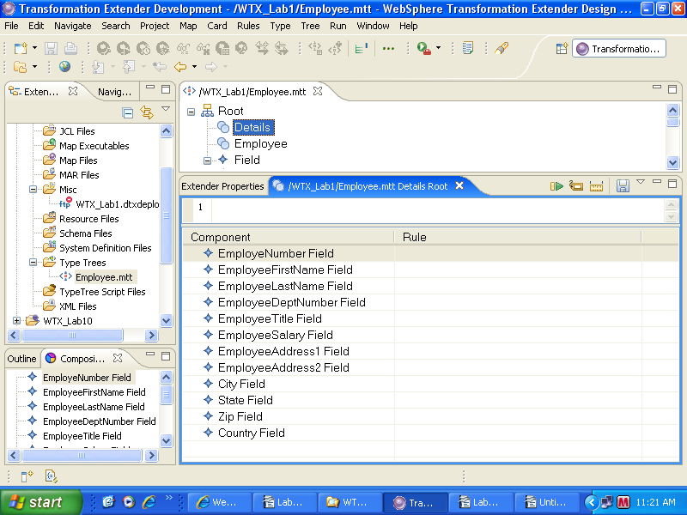

Step 14 :

Double click on Employee Group and drag the Details Group to Employee component window as shown below.

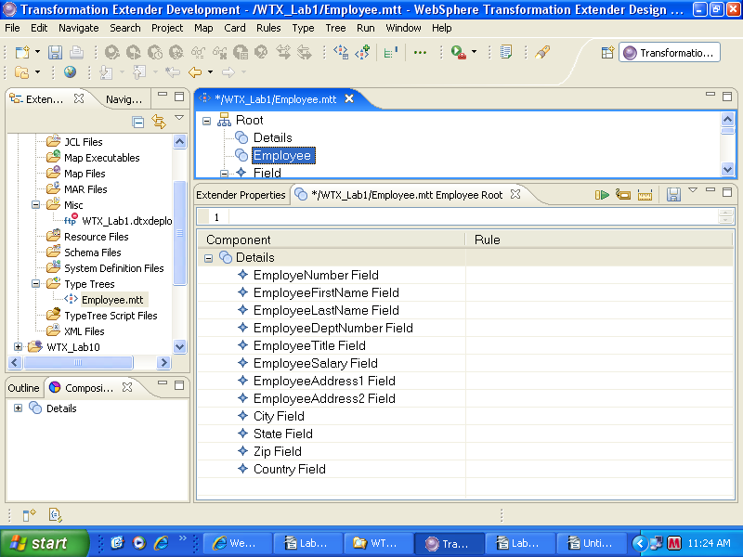

Step 15:

Padding a component range - Right click on Details and select the set Range as “0” to “s” (for Repeating records multiple times in input file).

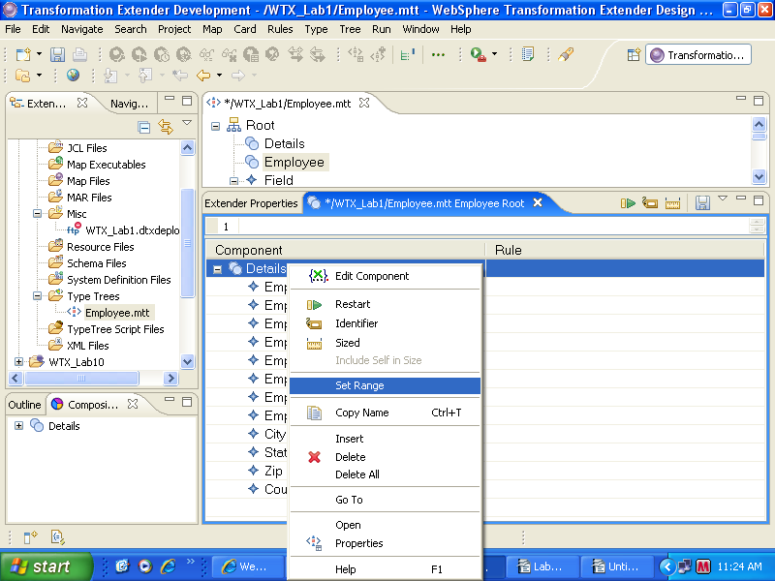

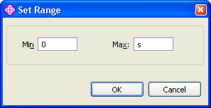

Step 16 :

Analyze the tree for logical errors and inconsistencies. From the menu, choose Tree -> Analyze -> Structure and Logic.

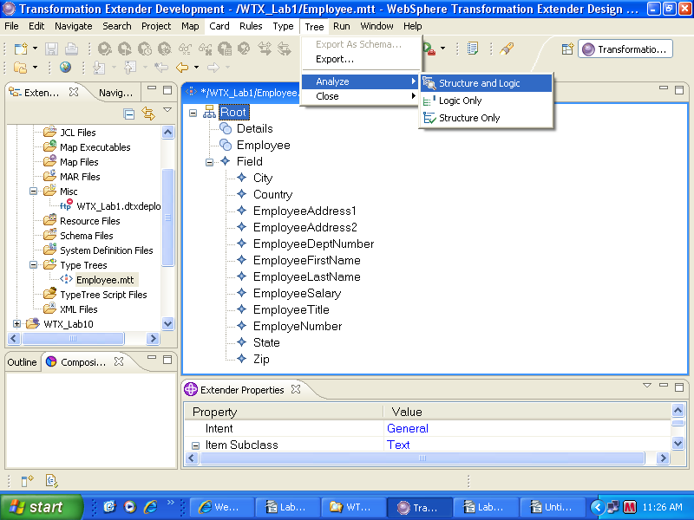

Step 17 :

Close the Analyze Results window and Save the typetree by going to the menu, choose File→Save (or use the Save icon from the toolbar) to write the changes to disk.

The tree is now rePady to be used in a map.

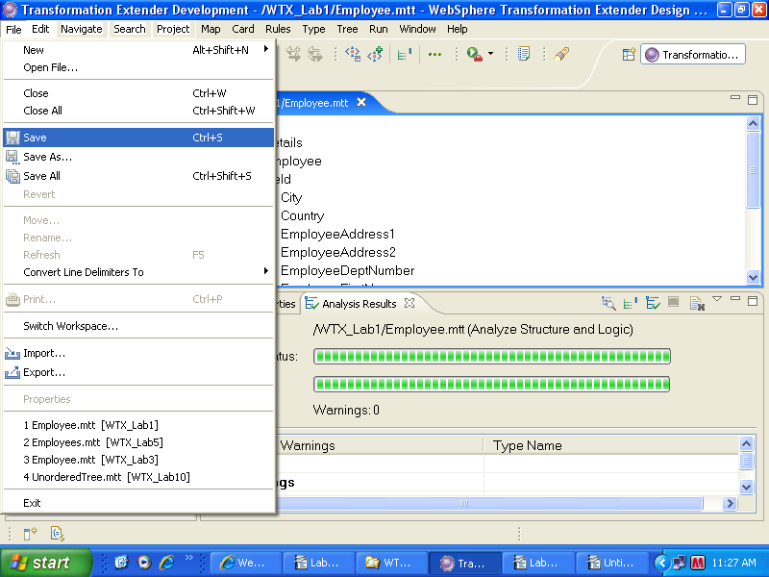

Limitations & Constraints:

Appendix A

Variable Delimiter

For the Delimiter property, specify whether the delimiter is a literal or a variable value.

Sometimes you do not know what delimiter is used in the data source, especially if you receive data from an outside source. However, you know all of the possible values that the delimiter could be. You can create an iItem to represent this delimiter and specify all of the possible values as restrictions of that iItem. The value of the delimiter in the data is found.
To specify an iItem as a Variable Delimiter:
- In the Properties window for the delimited group, click in the Delimiter IItem value field.
- Press Alt and drag the iItem from the type tree window into the Item field.

Appendix B

Padding

PPad characters are used to pPad the data to a specified length. Input data may contain both content and pPad characters. Output data is built according to the pPad definitions of the types .

Setting Pad option as YES - enables the Padding. Allows the iItem to contain both content and pPad characters. PPad properties include:
- Pad > Value
- Pad > Padded to
- Pad > Justify
- Pad > Apply Pad
If pPad value is no then data is assumed to be content on input; no pPad characters are built on output.

